Hall of Fame

2022

Winners: Shruto Kalyan Dey, Siddhartha Bondopadhyay (The Heritage School, Kolkata)

First runners-up: Varun Sinha, Soham Pednekar (Pewar Public School, Mumbai)

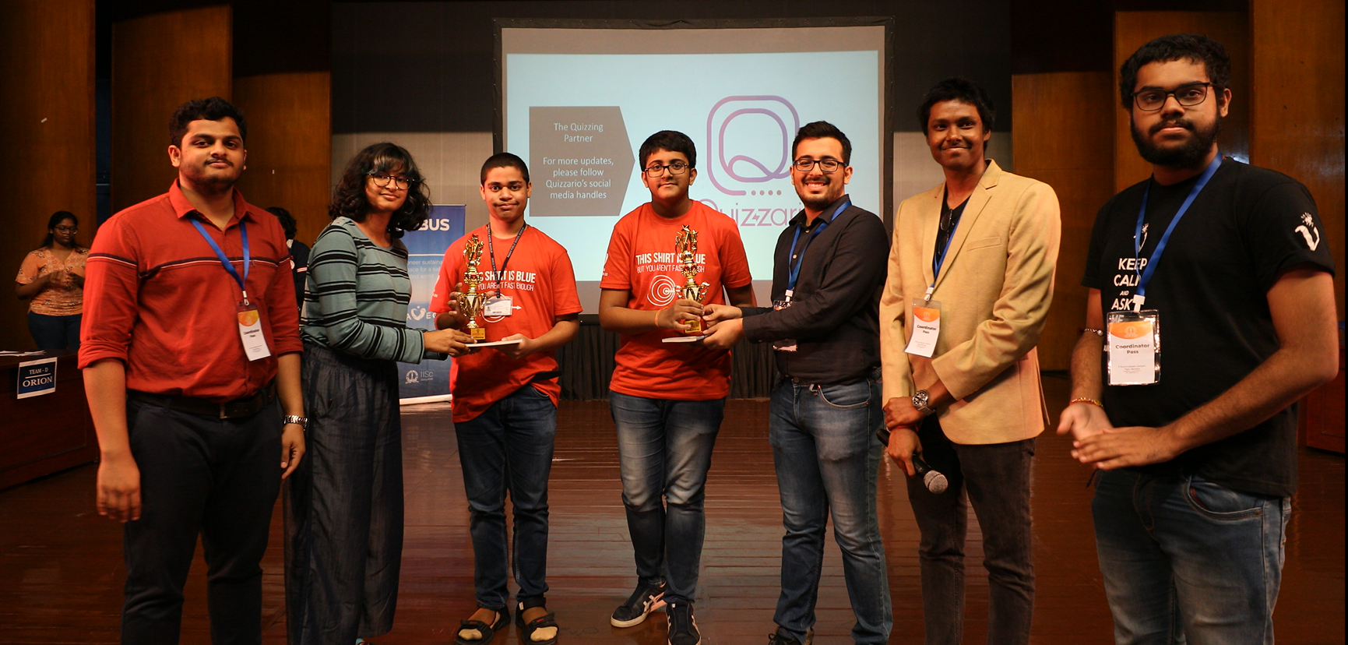

Second runners-up: Nidhish Palanikumar, Darshana Ambulkar (St. Paul’s English School, Bengaluru)

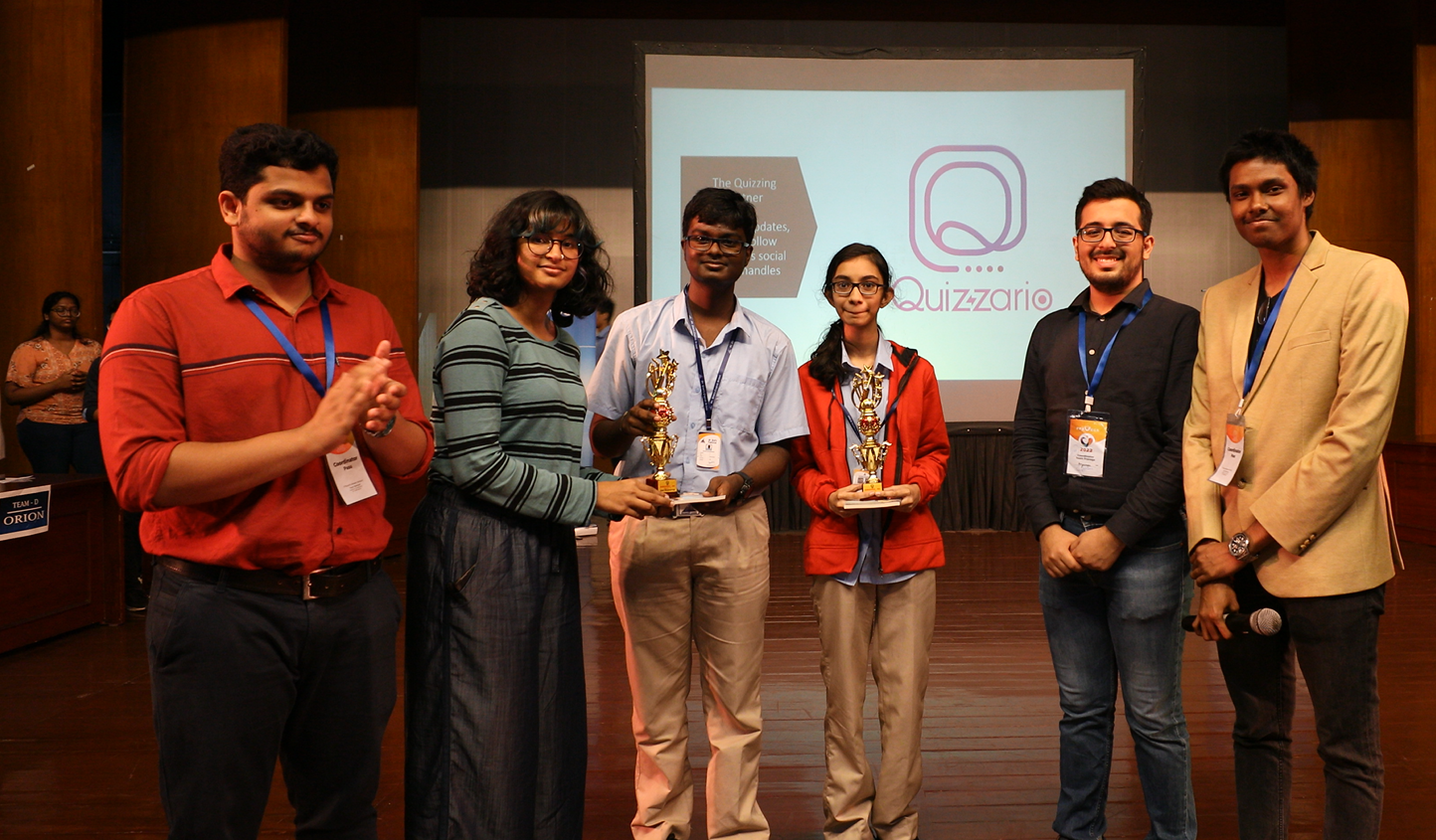

2021

Winners: Muralidhar Rao M, Ketan Suman, Varun Acharya, Ankith Kini

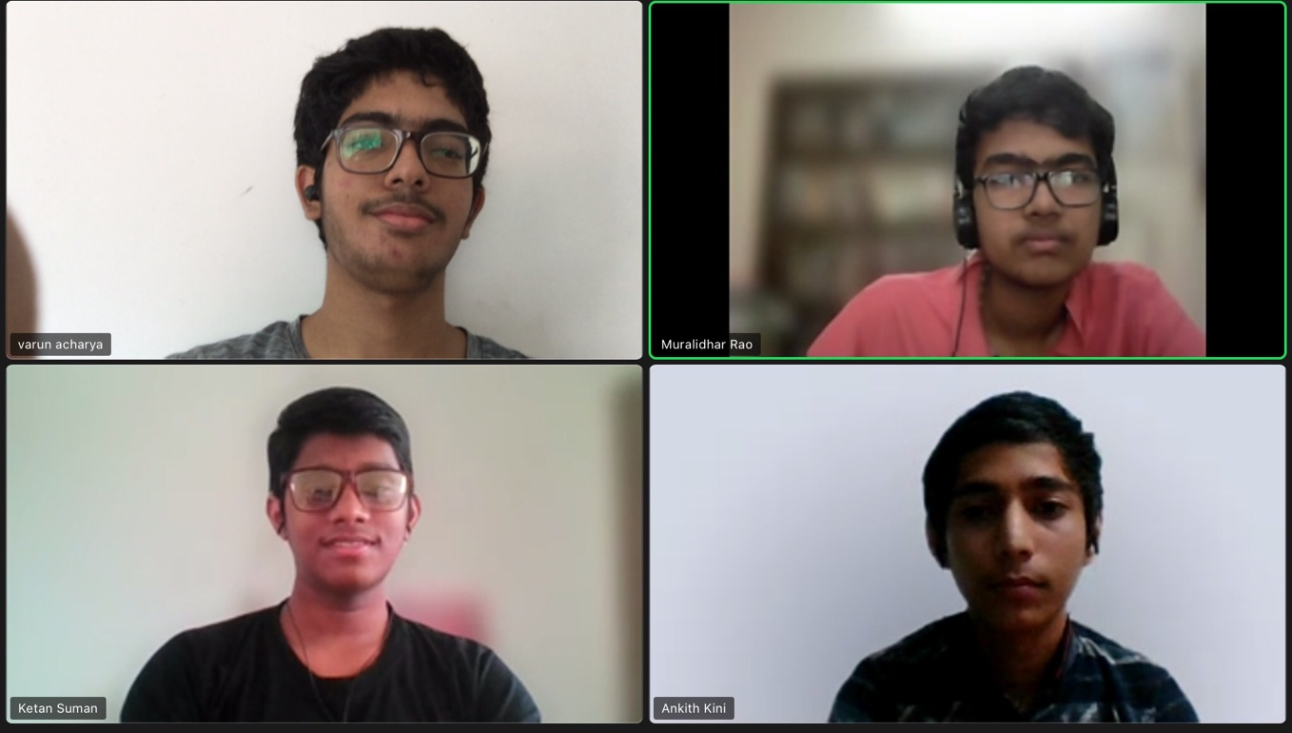

First runners up: Aaditya Kumar, Sainavaneet Mukund, Mohammed Emaad Arif, Krishnan Ramanarayanan

Second runners up: Shaurya Agrawal, Pranshul Bohra, Varun Marar, Pratik Sahoo

